HOW TO FILE CRIMINAL TRIAL EXHIBITS (Attorney instructions) | 7/17/2024

REFERENCE
Local Rule 83E(d) – Exhibits

Custody with Clerk of Court. All exhibits offered or received into evidence at a trial or hearing must be electronically filed via ECF by the party offering the exhibit. If an exhibit cannot be electronically filed (such as physical evidence) it must be left in the custody of the Clerk of Court, except as provided in sections (e) and (f) of this rule. Until judgment in a case becomes final, exhibits may not be taken from the custody of the Clerk of Court, except upon order of the court and the execution of a receipt.

HOW TO FILE

Generally, only one docket entry should be used for filing all exhibits admitted in trial and one docket entry should be used for filing all exhibits offered but not admitted in trial. However, in instances where you need to file both sealed and unsealed exhibits, you will create one entry for sealed exhibits and one entry for unsealed exhibits.

UNSEALED EXHIBITS

Only one docket entry should be used for filing all unsealed exhibits. DO NOT create an individual docket entry for each exhibit.

- Go to the Criminal tab
  - Go to Other Filings
    - Select Notices
    - Select: Notice of Filing of Exhibit(s)
- Next
- Enter the case number
- Next
- Next
- Next

- Select from the choices on the below screen:
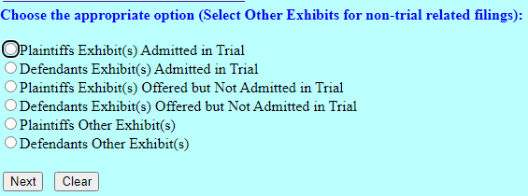
- Next
- On the document attachment screen:
- Main Document – attach the Notice of Filing Exhibit form you completed (located under “Attorney Info” and then the “Forms” tab)
- Each unsealed exhibit should be a separate attachment

  - Each exhibit should be properly named
  - From the Category drop down menu select “Exhibit”
  - In the Description text box type the letter/number or description of your exhibit

DO NOT type the word “Exhibit” in the Description box
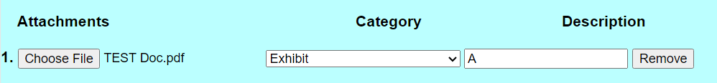

- For physical exhibits or thumb drive/CD/DVD delivered to the clerk’s office:

- A PDF place marker page should be created and uploaded with a description where the exhibit is located (see examples below)
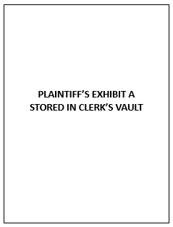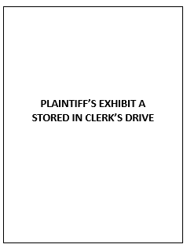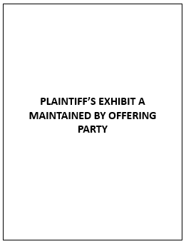

  - From the Category drop down menu select “Exhibit”
  - In the Description text box type the letter/number of your exhibit followed by one of the following:

    - “Stored on clerk’s drive” (i.e. thumb drives/CDs/DVDs)
    - “Stored in clerk’s vault” (i.e. physical exhibits)
    - “Maintain by offering party”

DO NOT type the word “Exhibit” in the Description box
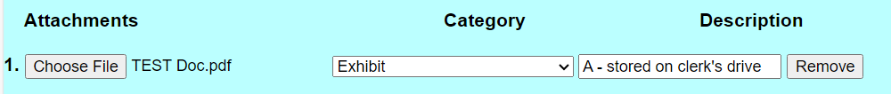

- After all of the unsealed exhibits or place markers have been uploaded and named, click Next
  - Select the party filing the document
  - Click Next
- The next screen will ask if you want to link this entry to another document filed in this case. You must link this entry to the last day of trial minute entry
- Put a check in the box

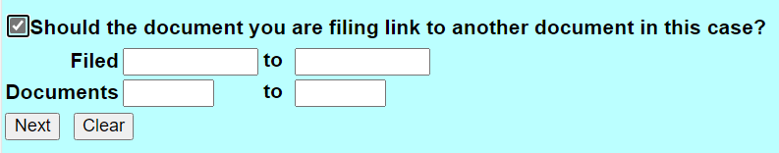
- Click Next

- The next screen will pull up the docket with the documents you can link to
  - Find the Minute Entry for the last day of the trial
  - Click the box on the left to select the entry you are linking to
  - Next
  - Next
  - Click Next to finalize your filing

SEALED EXHIBITS

Only one entry should be used for filing all sealed exhibits. DO NOT create an individual docket entry for each exhibit.

- Go to the Criminal tab
- Go to Sealed Document – Docket Text Public
  - Select: Sealed Other Documents – Docket Text Public
    - Select: Notice of Filing of Sealed Exhibits (SEALED) AP-DTP
- Next
- Enter the case number
- Next
- Next
- Next
- Next
- Next

- Select from the choices on the below screen:
- Next
- On the document attachment screen:
- Main Document – attach the Notice of Filing Exhibit form you completed (located under “Attorney Info” and then the “Forms” tab)
- Each sealed exhibit should be a separate attachment

  - Each exhibit should be properly named
  - From the Category drop down menu select “Exhibit”
  - In the Description text box type the letter/number or description of your exhibit

DO NOT type the word “Exhibit” in the Description box

- For physical exhibits or thumb drive/CD/DVD delivered to the clerk’s office:

- A PDF place marker page should be created and uploaded with a description where the exhibit is located (see examples below)

- From the Category drop down menu select “Exhibit”
  - In the Description text box type the letter/number of your exhibit followed by one of the following:

    - “Stored on clerk’s drive” (i.e. thumb drives/CDs/DVDs)
    - “Stored in clerk’s vault” (i.e. physical exhibits)
    - “Maintained by offering party”

DO NOT type the word “Exhibit” in the Description box

- After all of the unsealed exhibits or place markers have been uploaded and named, click Next

- The next screen lets you select who should have access to the sealed exhibit entry. Select the appropriate parties by holding down the CTRL key and using the mouse to select multiple parties as instructed below, click Next

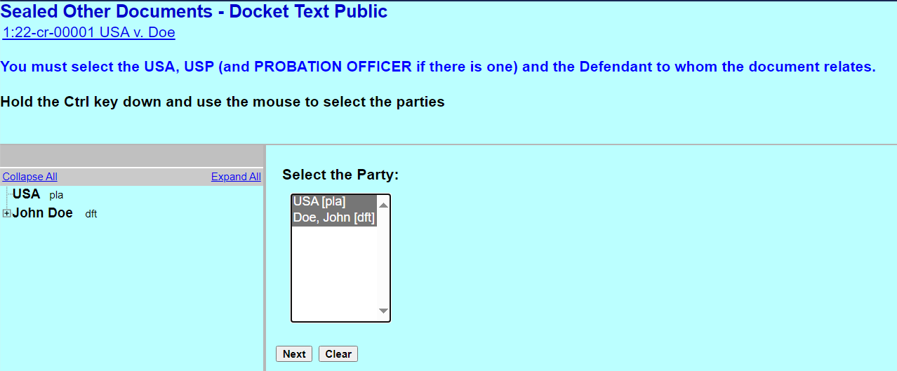

- The next screen will ask if you want to link this entry to another document filed in this case. You must link this entry to the last day of trial minute entry

  - Put a check in the box

- Click Next

  - The next screen will pull up the docket with the documents you can link to
    - Find the Minute Entry for the last day of the trial
    - Click the box on the left to select the entry you are linking to
    - Next
    - Next
    - Click Next to finalize your filing

